Recursion Worksheet 1 Name_________
Some MATH !!!

x*x + 1, if x<5 FIND : (a) f(0) 1
f(x) = x*x - 3, if x = 5 (b) f(6) 17
f (x-2), if x > 5

x + 3, if x <=3 FIND: (a) f(0) 3
f(x)= -x * f (x-1), if 3 < x < 5 (b) f(4) -24
f (x-2)*f (x-1), if x>=5 (c) f(5) -144

3) Trace the following program. Show the final output in the rectangle provided as well.

public class Recursion1{
Output:
13

public static void main(String[] args){
int num = 10;
System.out.println(mystery(num));
}
public static int mystery(int myNum){
if (myNum < 2)
return 3;
else
return 2 + mystery(myNum – 2);
}
}

4. What is the output of the program in Exercise #1 if the original value of the variable num is 1 instead of 10?
3

5. Trace the following program. Show the final output in the rectangle provided as well.

public class Ch17Worksheet1Ex3{
public static void main(String[] args){
Output:
7
int num = 13;
System.out.println(mystery(num));
}

public static int mystery(int myNum){
if (myNum <= 0)
return 0;
else
if (myNum % 2 == 0)
return 2 + mystery(myNum – 1);
else
return 1 + mystery(myNum – 2);
}
}
6. Study the function definition below. What would be the output of the call cheers(3)?
void cheers(int n){
if (n==1) System.out.println("hurray!");
else{
System.out.println( "Hip ");
cheers(n-1);
}
}
Hip
Hip
hurray!
- Evaluate f(12,6), given that 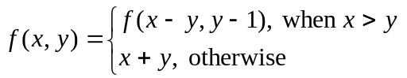.
5
Sample code:
int f(int x, int y)
{
if (x <= y)
return (x + y);
else
return f((x - y), (y - 1));
}

8. The function f is defined 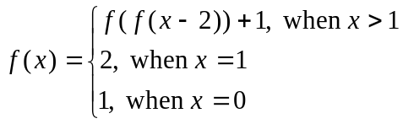.
Write a Java function public static int f(int x) which evaluates f at any positive integer x.
public static int f(int x)
if (x>1){
return f(f(x-2))+1;
}
If(x==1){
return 2;
}else{
return 1;
}

7) Write a recursive method called goldenRatio that takes an integer input N and computes an approximation to the golden ratio using the following recursive formula:
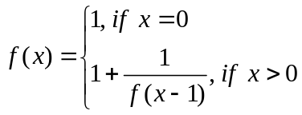

public static int goldenRatio (int x){
if (x == 0)
return 1;
else if ( x > 0)
return 1 + (1 / goldenRatio(x – 1));

